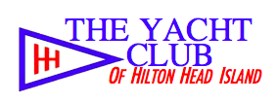

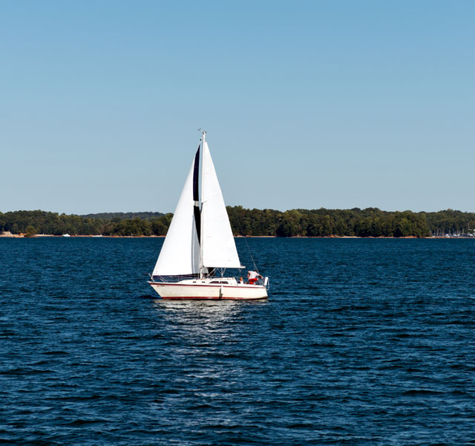

Guide to Joining the Club

Table of Contents

- Who is the Yacht Club of Hilton Head Island?

- Benefits of Membership

- Cost of Membership

- Application Process

Who is the Yacht Club of Hilton Head Island?

The Yacht Club of Hilton Head Island was founded in 1971 and is the oldest yacht club on the island.

Members are from all walks of life and we share a passion for being on the water and the laid-back life style. We are a boating club and a social club. We are a volunteer club.

The primary purpose of the club is to provide activities to members that are fun and enriching. We do this by providing a variety of boating activities and a dynamic social calendar.

Power boat members have a lively schedule of taking members to different destinations usually for lunch during the boating season. Destinations include Beaufort, Tybee Island, Savannah and Dawtaw Island.

Sailboat members have a Flying Scot racing schedule in the spring and fall. Members with larger sailboats often take members out sailing for a day on the water.

Members are good neighbors on the water and on land. We care about the environment of our waters. We are involved in our community. During the holidays the club collects food and donations for Deep Well and other activities.

We are grateful to live on Hilton Head Island and to enjoy our special waters.

You need not own a boat to be a member
Benefits of Membership

On-The-Water

- Power boating and sailing opportunities

- Learn to sail

- Free boat usage (Flying Scot & Sunfish)

Social

- Catered dining ever Friday evening (best deal on the island!)

- Special events and parties
Super Bowl, Kentucky Derby, Wine Tasting, Cook-Offs, Trivia Night, Pizza Night, Guest Speakers, and more!!!

- Use of our lovely Club facilities for free for small groups or rental for larger groups

- Friendship Opportunities

Community Service Boating

- Hilton Head Heroes (Families with a child suffering a life threatening or terminal illness) Day on the Water

- Boys and Girls Club – Learn to Sail and a Day on the Water

- Wounded Warriors – Day on the Water

RECIPROCITY WITH HUNDREDS OF OTHER YACHT CLUBS!!!!!

Visit Member Clubs While You Are Traveling

YOU. WILL. HAVE. FUN.

You Will Meet Very Nice People.
We Are A Friendly Group.

Cost of Membership

The cost to belong to the Yacht Club of Hilton Head Island is very reasonable and affordable.

One time application fee $100

Per Year and Per Person

Single Membership $ 550 $137.50 per quarter

Non-Resident Member $ 550 $137.50 per quarter

No monthly minimum

THE BEST VALUE ON THE ISLAND

You have many choices on the island if you want to belong to a club. By joining the YCHHI you will receive countless benefits for you, your family and friends.

When compared to other island clubs, the Yacht Club of Hilton Head is an incredible value and very affordable.

Application Process

Pick up an application at the club or contact us and we will send you one. You will need a sponsor who is a current member. If you do not have a sponsor contact the Membership Chair – Candice Hough at
Email: candice.m.hough@gmail.com

Board of Stewards
Once your application is received the Board of Stewards will review the application and vote.

New Member Orientation
After being accepted into the club you will be invited to a New Member Orientation meeting that will explain how to become involved in the club and our many activities.

It Is That Simple!!

What is better than hanging out with people who truly enjoy the same things as you?

Membership in the YCHHI provides you the opportunity to join an entire social circle of like-minded people that appreciate good friends, great food, wonderful boating and having fun!

So, there you have it. Let us know if you have any questions.

